
A 10
Sreenidhi Institute of Science & Technology
(An Autonomous Institution)
Code No: 101MA01/111MA01

B. TECH. I – Year I – Semester Examinations, May, 2012 (Supplementary)
ENGINEERING MATHEMATICS – I ( Common to all branches )

Time: 3 Hours Max. Marks : 70

Note : No additional answer sheets will be provided.

Part-A (Objective Type)
Max.Marks:20

Answer all QUESTIONS.

1. Find the Eigen values of the matrix 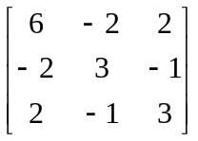
2. Find the value of K such that the rank of the matrix 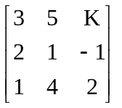is 2.
3. Reduce the quadratic from 2x₁x₂+2x₁x₃-2x₂x₃ to a canonical form.
4. Determine the nature of the series 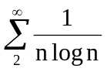.

5. In the mean value theorem f(b) - f(a) = (b-a) f '(c), determine c lying between a and b, if f(x) = x(x-1) (x-2), a = 0, b = 1/2.

6. Find the radius of curvature at (0,c) of the catenary y = c Cosh (x/c).

7. Find the asymptotes of the curve y³-2xy²-x²y+2x³+3y²-7xy+2x²+2y+2x+1=0.
8. Show that Sinx(1+cosx) is a maximum when x = 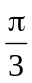.
9. Change the order of integration to evaluate 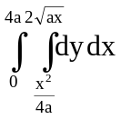.
10. Evaluate 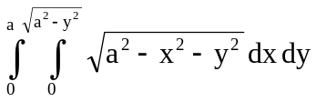.
Part – B
Max. Marks: 50

ANSWER ANY FIVE QUESTIONS. EACH QUESTION CARRIES 10 MARKS.

1. Find the rank of the matrix by reducing to normal form.
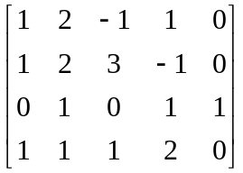.

2. Diagonalize the matrix A = 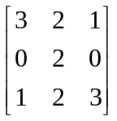.
3. Reduce the quadratic form to canonical form.
4. a) Test the convergence of the series 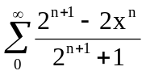. [ 5 ]
b) Discuss the convergence of the series 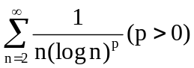. [ 5 ]
5. a) If x = r cosθ, and y = r sinθ , then find 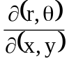. [ 5 ]
b) If 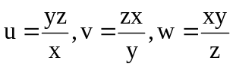, then prove that 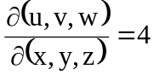. [ 5 ]
6. a) If ρ₁ and ρ₂ are the radii of curvature at the ends of a focal chord of the parabola y²=4ax, then show that 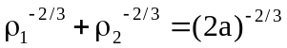. [ 5 ]
b) Find the envelope of system of concentric and coaxial ellipses of constant area.
[ 5 ]
7. Using Lagranges mean value theorem, show that 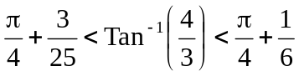.
8. a) Evaluate 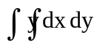, where R is the region bounded by the parabolas y²=4x and x²=4y.
b) Evaluate 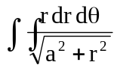over one loop of the lemniscate r²=a²cos2θ
-- 00 -- 00 --

